London Men's Open Championships 2015
Sponsored by Gymnova and Westmeria
Thursday 24th to Sunday 27th September
The Jean Brown Arena, Redbridge Sports Centre, Forest Road, Barkingside, IG6 3HD

Table of contents
P. 1 Introduction

P. 2 – 5 Venue Information
- Directions
- Parking
- Tickets
- Results sheets
- Venue Rules
- Merchandising
- Café
P. 6 Event Personnel
- Event Team
- Medical provision
P. 7 – 9 Technical information
- General Rules
- Gymnast registration
- Draw & Start List
- Judges meeting
- Coaches meeting
- Equipment Specs
- Podium Training
- Clubs
- Supervising coaches
- Assisting coaches
- Gymnasts
- Judges
- Anti-Doping
- BG/LG Photo Policy
P. 10 – 13 Competition details
- Warm Up Times
- Warm Up Rules
- Gymnast’s attire
- Coach’s attire
- Judges attire
- Competition Etiquette
- Electronic communications
- Inquiries and protests
- Tie breaks
- Scoring and results
- Awards & Ceremonies
- March Around
- Coaches Refreshments
- Social Media
Appendix One: Parents letter (can be downloaded from http://bit.ly/MLO2015 )

Introduction
Thanks very much for entering this year’s London Men’s Open Championships.
Every year we reach a new record number of entries and this year is no different with over 600 gymnasts competing over four days of competition (we literally can take no more!).
Let me say up front that we apologise to those clubs, parents and gymnasts affected by us moving Club Level 4, 5 and 6 to Thursday. We were left with little choice other than cancelling these competitions.
So as you can see we have a very busy weekend in store and will therefore be a long one, with the timings being extremely tight on all days. We always rely heavily on participating clubs to play their part in keeping us on schedule. Please ensure that you, parents and gymnasts arrive in plenty of time.
I am grateful to those clubs who have nominated a judge and you should by now have received the judges draw, but if not please let me know.
This year we have moved to Redbridge Leisure Centre. The centre has a lot of space with the main sports hall on the ground floor, other amenities on the 1st floor and a large dance studio for general warm up on the 2nd floor.
IT IS ESSENTIAL TO SHARE THIS WORKPLAN WITH COACHES, JUDGES AND PARENTS.
We expect a lot of interest for tickets, so please ensure you use our online ticket service prior to the event (NB on the door price does not include the online discount).
http://bit.ly/Londonopentickets
Finally I wish you a safe journey to London, and should you have any quires please do not hesitate to contact myself on 07545 352388 or email info@menslondonopen.co.uk . You can stay up to date with information for the championships by following our Facebook page https://www.facebook.com/LondonGymnastics or by visiting www.menslondonopen.co.uk .
Kind Regards
Lorna Goddard
Competition Director

Venue information - Directions
Venue title: The Jean Brown Arena, Redbridge Sports Centre, Forest Road, Barkingside, IG6 3HD
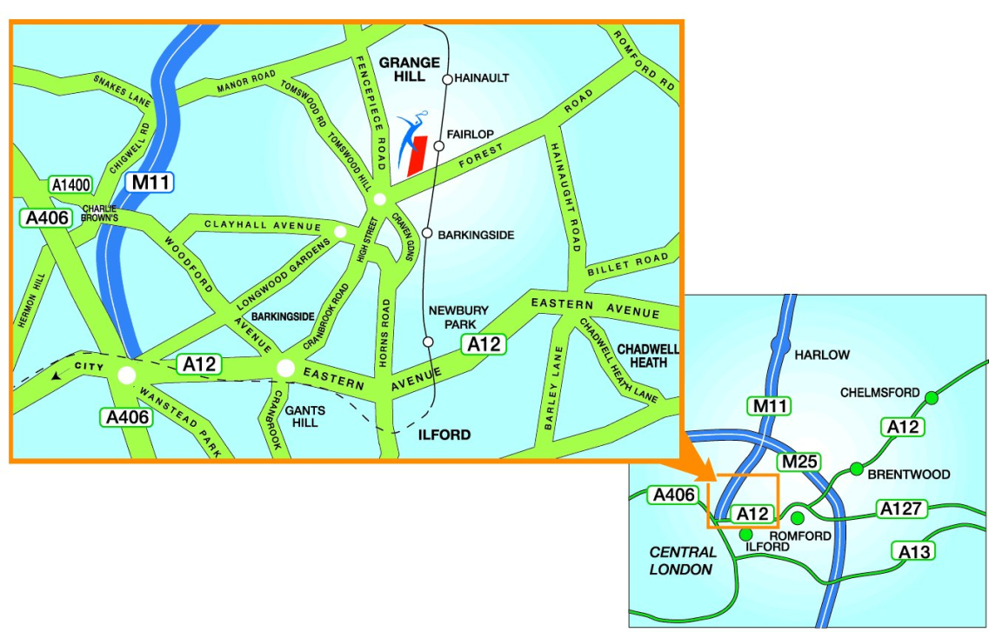
Directions:
Hainault Rd
NOT
Hainaught Rd

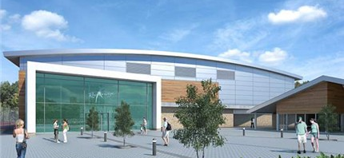
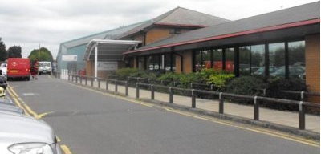
On arrival at the Centre follow the road below PAST the first sports centre (red van pictured in photograph). The competition venue is the silver building top left. The Jean Brown Arena competition venue is pictured RIGHT. Please enter through the glass doors at the front and follow directions. London event staff (turquoise polo shirts) will be able to direct you.
Ample FREE parking is available.
From the M11: At the end of the M11, take the left hand fork towards The City and A12. Take the first exit and at the roundabout at the end of the slip road take the first exit onto Redbridge Lane East. Go across several mini roundabouts and, when coming to a large one, go straight over into Longwood Gardens. Continue along Longwood Gardens (over some more mini roundabouts!) until you get to another slightly larger one. Turn right at this roundabout into Fremantle Road.
At the traffic lights, turn left into Barkingside High Street. Carry on down until you reach the main roundabout. Take the third exit into Forest Road. The Centre is about 100 yards up on the left hand side just before the railway bridge.
From the North Circular Eastbound: Take the A1400 exit off the North Circular (just before the M11). At the roundabout take the 2nd exit towards Southend and the A127. Go over a set of pedestrian lights and at the next set of lights take the left hand turn into Clayhall Avenue. Go straight up Clayhall and at the roundabout go straight over (effectively the first exit.) At the traffic lights turn left into Barkingside High Street. At the next roundabout take the third exit into Forest Road.

By Underground: We are located next to Fairlop Tube Station on the Central Line.

Venue Information - Tickets:
Ticketing: The London Open Championships is often a sell-out event. Therefore we suggest you book your tickets early to avoid disappointment.
You can also receive a discount when you purchase tickets online.
You can do so via phone or over the web - just follow our link below.
Online Sales: http://bit.ly/Londonopentickets
To book tickets over the phone, please call: 020 8410 4443
Card Payments: We have a PayPal terminal to take card payments on the door
Exceptions: Gymnasts & Coaches taking part in other competitions can watch the Westminster Cup for £5.00 from the designated seating (should be booked in advance)
Wristbands will be issued instead of tickets. If you are issued with a ticket prior to the event, please exchange this for a wrist band upon arrival. These should be worn at all times to help our stewards easily identify that you have paid.
It may be necessary to clear the hall between rounds on the grounds of health and safety.
 | Thurs 24th PM  Club L4-6 | Fri 25th  AM  Elite L1 | Fri 25th  PM  Elite L2-4 | Sat 26th AM  Loveday & Clayton | Sat 26th  PM  Westminster | Sun 27th  All Day  Club L1-3
Standard Ticket ONLINE | £5.50 | £10.50 | £10.50 | £10.50 | £15.75 | £10.50
Standard Ticket  On the Door | £7.00 | £13.50 | £13.50 | £13.50 | £16.50 | £13.50

Result sheets Available at the end of each competition at a cost of 50p.
Venue Rules 1. Whilst we are keen to encourage strong spectator participation, please ensure that sound instruments or Claxton’s are only used between the march around of the gymnasts.
2. Parents should avoid eating in the bleacher seating
3. Please follow the direction of stewards at all times
4. Please only leave your seat between rounds
5. No Flash Photography, please also ensure bright lights on your mobile device are turned off.
6. London Gymnastics & Redbridge SC uses a zero tolerance approach to abuse against our volunteers. You will be required to leave the premises if deemed to have contravened this rule.
Merchandising There will be a range of merchandising stalls which will be available throughout the Championships (though some stalls may not be open for each round of competition).
The Zone Stall – Major sponsor to London Gymnastics will be selling a wide range of boys and girls gymnastics attire
Fine Design – selling a range of garments which can have print transfer added to them on site
Photo Opportunities – Throughout the weekend a crew from Photo Opportunities will be on the competition floor capturing key moments from the competition. Prints can be ordered on site or via the website at a later date.
Café The onsite café will be open throughout the weekend and offer a range of hot and cold refreshments

Event Personnel:
Competition Director: Lorna Goddard
General Manager: Ben Murphy
Front of House: Anne McNeill
Technical Director/ Trevor Low
Appeals:
Judging Convenor: Andy Tombs and Graham O’Sullivan
Field off Play Manager(s) Wendy Streeter, Natalie Stocks and Penny Deane
Medical provision: There will be a first aider present during the event, including two British Gymnastics appointed Physiotherapists.
The first aider/Physio may be contacted through the competition control desk.
Welfare Officer; There will be a welfare officer on duty during the event. The welfare officer may be contacted through the competition control desk.
Announcer: Ben Murphy & Steve Frew

Technical information
General Rules All entry fees are non-returnable
Please check through the start list of names, check that gymnasts have been entered in the correct level and that the spelling of their name is correct.
Please ensure that your gymnasts arrive at least 30 minutes before the stated registration time, except for the first round.
Gymnast registration: Registration of gymnasts will take place on the 1st Floor landing area (follow signs). Coach, parent or gymnast may register via online screens. Photographs will also be taken at this point (for display on the arena screens).
Please ensure you inform us of any withdrawals at registration (or to the Competition Director if known prior to the event).
Depending on the competition running time, Registration Officers will direct gymnasts to the Warm Up area on the 2nd Floor (no parents allowed past the stairs on the 1st floor), or to the spectator seating until called for warm up.
London Development gymnasts wanting to claim their free T-Shirt should collect their voucher from Registration and redeem it on the Fine Designs Stall.
Draw & Start List: The latest draw can be found here:
http://bit.ly/OpenStartList
If groups become unbalanced due to withdrawals, we reserve the right to adjust group numbers on the day (up until the start of apparatus warm-up) to facilitate continuity of the competition.
Judges meeting: Thursday 24th (2nd Flr Dance Studio) 17:15
Friday 25th (2nd Flr Dance Studio) 07:45
Saturday 26th (1st Floor Balcony Studio) 08:00 / 18:15
Sunday 27th (1st Floor Balcony Studio) 07:30
Coaches meeting: There will be a coaches meeting with the Competition/Technical Director at the Control Table shortly before warm-up commences
Equipment Specs: Gymnova is the official equipment supplier. No other equipment may be used without 24hrs notice to the Competition Director.
Equipment Heights and Matting as per Club & Elite Grade Handbooks, National MTC Handbook and FIG Code of Points.
It is the responsibility of the gymnast to bring their own loops and gloves.
Podium Training: Podium training will be available for Open gymnasts on Friday evening from 20:00 – 21:30.
Clubs: Must be BG registered, with London entries affiliated to
London Gymnastics
Supervising coaches: Must have a current paid Gold BG membership, Current BG DBS & SPCA, & minimum level 2 qualification.
Assisting coaches: Must have current silver BG membership, DBS, SPCA & minimum level 1 qualification.
Level 1 assisting coaches must be coaching within their coaching qualification and be supervised by a Level 2 coach.
Note: If you wish to use any coaches who were not nominated on your original entry, please contact the Competition Organiser
Gymnasts: Must have current BG Bronze membership for Regional Competitions and Silver Competitive membership for National Competitions.
Judges: Judges require a current minimum Bronze BG membership & relevant judging qualification
Anti-Doping London Gymnastics follows the BG anti-doping statement.
“The anti-doping rules of British Gymnastics are the UK Anti-Doping Rules published by the Drug Free Sport Directorate of UK Sport (or its successor), as amended from time to time. Such rules shall take effect and be construed as rules of British Gymnastics.”

BG/LG Photo Policy: By entering an LG event, there is an acceptance that the participants may be photographed and the photograph may be published in LG communications. Any person wishing to use video, film, or take photographs must abide by the BG ‘Photography at Events’ Policy. http://bit.ly/BGPhotopolicy
Photos may only be taken for personal use. You may not take photos for sale, other commercial use, or publications in printed or electronic form, such as on websites. Clubs may publish some photos of their own gymnasts, but this may only be done in accordance with BG ‘Child Protection’ Policy
Flash may not be used at any time whilst gymnasts are warming up or competing. Any concerns about any photographer or the suitability of any photos being taken should be reported to the Welfare Officer at the event.
Nominated coaches must not take photos or videos, whilst in the arena, with the exception of during presentations. Coaches who are spectators are covered by the same rulings as parents/guardians.

Competition details:
Warm Up Times: Please see below general and apparatus warm up times. Please pay attention to those rounds which use warm up and compete.
Times may be adjusted on the day to reflect withdrawals.
Thursday 24th
Round 1 Club Level 4:
General Warm-up: 15 Minutes (2nd Floor Warm Up Area)
Apparatus Warm-up: 4 minutes warm up immediately before each piece competes. VT – 2 Vaults
Round 2 Club Level 5/6:
General Warm-up: 15 Minutes (2nd Floor Warm Up Area)
Apparatus Warm-up: 4 minutes warm up immediately before each piece competes. VT – 2 Vaults
Friday 25th
Round 3 Elite Level 1 (9+):
General Warm-up: 15 minutes (2nd Floor Warm Up Area)
Apparatus Warm-up: 1 minute per gymnast apparatus warm up (7 minutes) immediately before each piece competes. VT – 2 Vaults
Round 4 Elite Level 1 (U8):
General Warm-up: 15 minutes (2nd Floor Warm Up Area)
Apparatus Warm-up: 1 minute per gymnast apparatus warm up (5 minutes) immediately before each piece competes. VT – 2 Vaults
Round 5 Elite Level 2:
General Warm-up: 15 minutes (2nd Floor Warm Up Area)
Apparatus Warm-up: 1 minute per gymnast apparatus warm up (5 minutes) immediately before each piece competes. VT – 2 Vaults
Round 6 Elite Level 3 & 4:
General Warm-up: 15 minutes (2nd Floor Warm Up Area)
Apparatus Warm-up: 1 minute per gymnast apparatus warm up (8 minutes) immediately before each piece competes. VT – 2 Vaults
Saturday 26th
Round 7 Clayton Bolt:
General Warm-up: 15 Minutes (2nd Floor Warm Up Area)
Apparatus Warm-up: 30 Minutes Open Warm Up before Competition starts.
30 Seconds touch per gymnast (2 Minutes) immediately before each piece competes.
Round 8 Clayton Bolt:
General Warm-up: 15 Minutes (2nd Floor Warm Up Area)
Apparatus Warm-up: 30 Minutes Open Warm Up before Competition starts.
30 Seconds touch per gymnast (2 Minutes) immediately before each piece competes.
Round 9 Loveday:
General Warm-up: 15 Minutes (2nd Floor Warm Up Area)
Apparatus Warm-up: 45 Minutes Open Warm Up before Competition starts.
30 Seconds touch per gymnast (3 Minutes) immediately before each piece competes.
Round 10 Loveday:
General Warm-up: 15 Minutes (2nd Floor Warm Up Area)
Apparatus Warm-up: 40 Minutes Open Warm Up before Competition starts.
30 Seconds touch per gymnast (2.5 Minutes) immediately before each piece competes.
Round 11 Westminster:
General Warm-up: 15 Minutes (2nd Floor Warm Up Area)
Apparatus Warm-up: 60 Minutes Open Warm Up before Competition starts.
30 Seconds touch per gymnast (3.5 Minutes) immediately before each piece competes.
Sunday 27th
Round 12 Club Level 1 (9+) & 2:
General Warm-up: 15 minutes (2nd Floor Warm Up Area)
Apparatus Warm-up: 12 minutes warm up immediately before each piece competes to be shared equally between A & B Groups. (6 Minutes each)
Round 13 Club Level 1 & 2 & 3:
General Warm-up: 15 minutes (2nd Floor Warm Up Area)
Apparatus Warm-up: 16 minutes warm up immediately before each piece competes to be shared equally between A & B Groups. (8 Minutes each)
Round 14 Club Level 1 (U8) & 3:
General Warm-up: 15 minutes (2nd Floor Warm Up Area)
Apparatus Warm-up: 12 minutes warm up immediately before each piece competes to be shared equally between A & B Groups. (8 Minutes each)
Warm Up Rules Finish Apparatus warm-up when announced.
Have the first gymnast and subsequent gymnasts ready to compete straight away
For gloves and loops, please ensure that your gymnasts put both hands in their loops. A simple nod will do to present to the judge.
Please utilise duplicate sets of apparatus
Gymnast’s attire: Gymnasts must march on in competition attire/ club tracksuits. Jewellery, body piercing and similar adornments are not allowed
Coach’s attire: In line with BG regulations, coaches must wear club tracksuit or polo shirt, t -shirt and long track bottoms. Footwear should be clean trainers or socks. Coaches will not be allowed on the floor if wearing inappropriate clothing or jewellery.
Chewing gum is not permitted at any time.
Judges attire: Judges and officials must wear black/blue suits, skirts or trousers with jackets and white shirts with black smart shoes.
Competition Etiquette: Please ensure that gymnasts and coaches use the seating provided whilst waiting to perform on the apparatus. Please keep all you belongings together and only march to the next piece of apparatus when instructed, ensuring that gymnasts march around the apparatus and not across it.

Electronic communications: Apart from as required for the running of the competition, gymnasts, coaches, judges and officials must not use mobile phones or any other electronic communication devices including tablets, to make calls, take photographs or be used for other forms of communication in the arena during the event.
Inquiries and protests Please refer to the BG MTC Competition Handbook. There will be no appeals in the London Development Open.
Tie breaks: In the event of a tied score, there will be no tie-break and tied gymnasts will have the same ranking.
Scoring and results: Scores will be shown after each performance on the big screens in the arena. A printed receipt with the score will be handed to coaches. Finalised score sheets will be sent to competing clubs. Scores will be published on the LG website. During the day please get live updates of scores via www.gymdata.co.uk
Awards & Ceremonies: London Open
Clayton Bolt Shield (Inters): This is for gymnasts registered with BG/Home Nations membership. Medals will be presented for All Around and Individual Apparatus.
Loveday Trophy (Youth & Junior): This is for all gymnasts registered with BG/Home Nations membership. Medals will be presented for All Around and Individual Apparatus.
Westminster Cup (Open Age): This is for all gymnasts registered with BG/Home Nations membership. Medals will be presented for All Around and Individual Apparatus.
Westminster Shield: This will be awarded to the highest placed London Gymnast and will be presented only for show (keep sake will also be given)
International Cup: This will be presented to the highest placed International Gymnast. The criterion for an ‘International’ gymnast is for a gymnast that has been invited from overseas by the London Gymnastics MTC. Those with BG Membership are not considered internationals for this purpose.
Disability Cup: This is for gymnasts registered with BG/Home Nations membership. Medals will be presented for All Around
Prize Money: All gymnasts that take part in all age groups are eligible for the prize money. The top 3 gymnasts will be awarded prize money.
Clayton Bolt: 3rd=£100, 2nd=£150 & 1st=£250
Loveday: 3rd=£150, 2nd=£200 & 1st=£300
Westminster Cup: 3rd=£200, 2nd=£250 & 1st=£500
Elite Performance & London Development Open
Medals will be awarded for all Elite Performance Pathway winners and to the winners of each In Age (and Under 8) champion in the London Development Open.
Individual Apparatus (Gold Only) will also be presented at each level but only where there are 6 or more gymnasts in a group.
Out of Age levels will only have All Around medals presented
Orion GC Team Prize
Elite team (£300): Awarded to the Club with the highest collective points in the London Men’s Open & Elite Grades
All around standings only (1st = 6pts, 6th = 1pt)
Club team (£250): Awarded to the Club with the highest collective points in the London Development Open
All around standings only (1st = 6pts, 6th = 1pt)
March Around: Please ensure the gymnasts quickly line up behind their marshall when instructed. The gymnasts need to follow their marshall to get to their next piece. Please ensure all coaches remain back behind the lines until ALL the gymnasts have marched to the judges on their panel.

Coaches Refreshments: Free tea and coffee is available for coaches ALL day in the warm up area.
Social Media: London Gymnastics has a strong Social Media Presence and will be ensuring the action from the event is shared as widely as possible. Please use the links below and interact with us using the #MLO2015 or #LondonGymnastics
Twitter@londongymnastic
Facebook.com/LondonGymnastics
Instagram/LondonGymnastics
Youtube.com/Londongymnasticsuk
AN EDITABLE VERSION OF THIS LETTER CAN BE FOUND ON http://bit.ly/MLO2015
To the Parent / Guardian of:
Venue: Redbridge Leisure Centre, Forrest Road, Barkingside, Essex, IG6 3HD
Directions, & Map can be found on http://bit.ly/MLO2015 (Free Parking Available)

Your child is competing on: Thursday 24th September/ Friday 25th September / Saturday 26th September / Sunday 27th Please arrive at the venue at (insert time)

As you go into the arena signs will direct you to where gymnasts or spectators need to go. Registration is on the first floor and gymnasts can register on arrival. Gymnasts should go with their parents / guardians to the spectator seating and wait to be called for their round. At NO time will any parents be allowed into the warm up area.

Warm Up will be at: (insert time) Competition will be at: (insert time) Followed by the Medal Presentation at (insert time) and will finish at: (insert time)
All times are subject to change if the programme is running early. Please note the competition will not be held up if your son does not arrive by registration time, the organisers reserve the right to begin half hour ahead of published timings except for in round one.

Tickets
The London Open Championships is often a sell-out event. Therefore we suggest you book your tickets early to avoid disappointment. You can also receive a discount when you purchase tickets online. You can do so via phone or over the web - just follow our link below.
Online Sales: http://bit.ly/Londonopentickets
To book tickets over the phone, please call: 020 8410 4443
Card Payments: We have a PayPal terminal to take card payments on the door
Exceptions: Gymnasts & Coaches taking part in other competitions can watch the Westminster Cup for £5.00 from the designated seating (should be booked in advance)
Wristbands will be issued instead of tickets. If you are issued with a ticket prior to the event, please exchange this for a wristband upon arrival. These should be worn at all times to help our stewards easily identify that you have paid. It may be necessary to clear the hall between rounds on the grounds of health and safety.
 | Thurs 24th PM  Club L4-6 | Fri 25th  AM  Elite L1 | Fri 25th  PM  Elite L2-4 | Sat 26th AM  Loveday & Clayton | Sat 26th  PM  Westminster | Sun 27th  All Day  Club L1-3
Standard Ticket ONLINE | £5.50 | £10.50 | £10.50 | £10.50 | £15.75 | £10.50
Standard Ticket  On the Door | £7.00 | £13.50 | £13.50 | £13.50 | £16.50 | £13.50
Result sheets
Available from the ticket desk at the end of each competition for a cost of 50p
Venue Rules
1. Whilst we are keen to encourage strong spectator participation, please ensure that sound instruments or Claxton’s are only used between the march around of the gymnasts.
2. Parents should avoid eating in the bleacher seating
3. Please follow the direction of stewards at all times
4. Please only leave your seat between rounds
5. No Flash Photography
6. London Gymnastics & Redbridge SC uses a zero tolerance approach to abuse against our volunteers. You will be required to leave the premises if deemed to have contravened this rule.
Merchandising
There will be a range of merchandising stalls which will be available throughout the Championships (though some stalls may not be open for each round of competition).
The Zone Stall – Major sponsor to London Gymnastics will be selling a wide range of boys and girls gymnastics attire and also London Gymnastics Merchandise.
Fine Design (Thurs & Sunday only) – selling a range of garments which can have print transfer added to them on site. Gymnasts in the Development Open will receive a ‘free t-shirt’ voucher (in registration) which can be redeemed at the stall.
Photo Opportunities – Throughout the weekend crew from Photo Opportunities will be on the competition floor capturing key moments from the competition. Prints can be ordered on site or via the website at a later date.
Café
The onsite café will be open throughout the weekend and offer a range of hot and cold refreshments
Scores can be viewed LIVE on the day of the competition by going to www.gymdata.co.uk
London Gymnastics has a strong Social Media Presence and will be ensuring the action from the event is shared as widely as possible. Please use the links below and interact with us using the #MLO2015 or #LondonGymnastics
Twitter@londongymnastic Facebook.com/LondonGymnastics
Instagram/LondonGymnastics Youtube.com/Londongymnasticsuk
NO FLASH photography can be used during the competition, please ensure lights on mobile devices are disabled.
Many thanks,
(Insert name of club)

